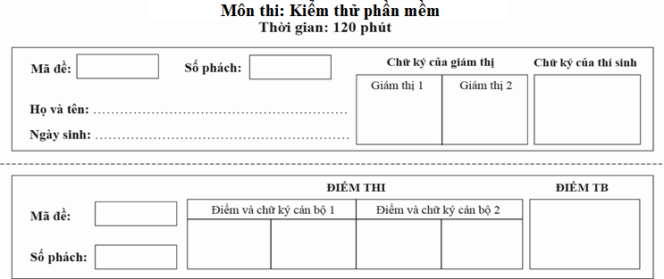

**No.1**

|  |  |  |  |  |  |
| --- | --- | --- | --- | --- | --- |
| 1 | A | B | C | D |  |
| 2 | A | B | C | D |  |
| 3 | A | B | C | D |  |
| 4 | A | B | C | D |  |
| 5 | A | B | C | D |  |
| 6 | A | B |  |  |  |
| 7 | A | B | C | D |  |
| 8 | A | B |  |  |  |
| 9 | A | B | C | D |  |
| 10 | A | B | C | D |  |
| 11 | A | B | C | D |  |
| 12 | A | B | C | D |  |
| 13 | A | B | C | D |  |
| 14 | A | B | C | D |  |
| 15 | A | B | C | D |  |
| 16 | A | B | C | D |  |
| 17 | A | B | C | D |  |
| 18 | A | B | C | D |  |
| 19 | A | B | C | D |  |
| 20 | A | B | C | D |  |
| 21 | A | B | C | D |  |
| 22 | A | B | C | D |  |
| 23 | A | B | C | D |  |
| 24 | A | B | C | D |  |
| 25 | A | B | C | D |  |
| 26 | A | B | C | D |  |
| 27 | A | B | C | D |  |
| 28 | A | B | C | D |  |
| 29 | A | B | C | D |  |
| 30 | A | B | C | D |  |
| 31 | A | B | C | D |  |
| 32 | A | B | C | D |  |
| 33 | A | B | C | D |  |
| 34 | A | B | C | D |  |
| 35 | A | B | C | D |  |
| 36 | A | B | C | D |  |
| 37 | A | B | C | D |  |
| 38 | A | B | C | D |  |
| 39 | A | B | C | D | E |
| 40 | A | B | C | D |  |
| 41 | A | B | C | D |  |
| 42 | A | B | C | D |  |
| 43 | A | B | C | D |  |
| 44 | A | B | C | D |  |
| 45 | A | B | C | D |  |

**-------End------**